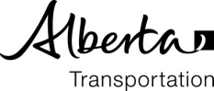
Post Construction Tri-Party Meeting
AGENDA

Project: | Contract #: | Contractor:
Consultant: | Alberta Transportation:
Date: | Time: | Location:

Distribution: Consultant, Contractor, Alberta Transportation Project Sponsor, Professional Services

- Introduction

- Traffic Accommodation & Safety

- Project Team Effectiveness / Communications

- Contract Administration

- Workmanship / Quality Control & Quality Assurance

- Environmental Issues

- Other

