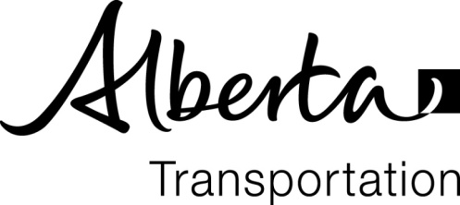
CERTIFICATE OF CALIBRATION

PROJECT NO: |  | CONTRACT NO:
CONTRACTOR: |  | DATE CALIBRATED:
PLANT TYPE, MAKE & MODEL:

I hereby certify that the asphalt plant has been calibrated to produce a uniform mixture in accordance with the specified mix.
The plant is accurate within the following range of production rates:
Aggregate Belt Scale or Aggregate Feed
From: |  | tonnes/hr | To: |  | tonnes/hr
Asphalt Proportioning System
From: |  | tonnes/hr | To: |  | tonnes/hr

Calibration Certified by:
Position:
Received by:
 |  | Consultant Signature*
Date Received: |  |  | Time:

*Signature indicated receipt of Calibration Certificate on the Date and Time indicated.

